**ABSTRACT**

A weather station is a facility equipped with high tech instruments for predicting future weather phenomenon. This is also used to study the climate of that area. The measurements taken from the station include temperature, humidity and air quality. The accuracy predicted by these weather stations is not too high to predict the actual weather condition for a particular area. The error difference may be around 10% which makes a huge difference. Plus, in every city there are 23 weather stations only for predicting weather of an area as wide as 426km sq. The weather stations give the prediction for the whole city and not just a particular area. Each area might have different climate since the weather depends on location. To know the weather conditions of our surroundings I developed this weather monitoring system.

INTRODUCTION

One of the IoT applications is real-time weather monitoring. We provide solution to the observatory to achieve real-time monitoring of weather at different locations in the territories covered by mobile network.

Weather monitoring means to monitor the changes in the weather. To serve this purpose we use two sensors namely dht11 and mq135. DHT11sensor has both temperature and humidity sensors used for detecting the temperature and humidity and Mq135 is a gas sensor for finding the air quality in the surrounding environment. The observatory can issue warning signal to the public immediately after poor weather condition is recognized.

We read the analog values A0,A1.A0 stores values of dht11 and A1 has values of mq135.The dht11 and mq135 has three pins gnd, vcc and data pins. The sensed temperature, humidity and air quality values are outputs of dht11 and mq135.Thes values are sent to Arduino through the data pins. Output values of the sensor are taken as inputs for the Arduino.

The GSM module sends notifications to the user in the form of text message. The GSM module has three led’s indicating its functionality. The three led’s are network led, status led and power led. The network led blinks when

**HARDWARE REQUIREMENTS**:-

Components required for the project are

* Arduino Uno
* Humidty and Temperature sensor
* Gas sensor
* Connecting wires

**Arduino Uno:**



**Arduino Uno** is a microcontroller board developed by Arduino.cc which is an open-source electronics platform mainly based on AVR microcontroller Atmega328.Arduino is an open source, PC paraphernalia and programming organization, endeavour, and client group that plans and produce microcontroller packs for constructing programmed devices and intelligent object that can detect and control questions in the real world. The inception of the Arduino extend began at the Interaction Design Institute in Ivrea, Italy. The equipment reference plans are appropriated under a Creative Commons Attribution Share.Arduino Uno comes with USB interface, 6 analog input pins, 14 I/O digital ports that are used to connect with external electronic circuits. Out of 14 I/O ports, 6 pins can be used for PWM output. Arduino Uno are the most official versions that come with Atmega328 8-bit AVR Atmel microcontroller where RAM memory is 32KB.When nature and functionality of the task go complex, Mirco SD card can be added in the boards to make them store more information.

**Humidity and Temperature Sensor:**

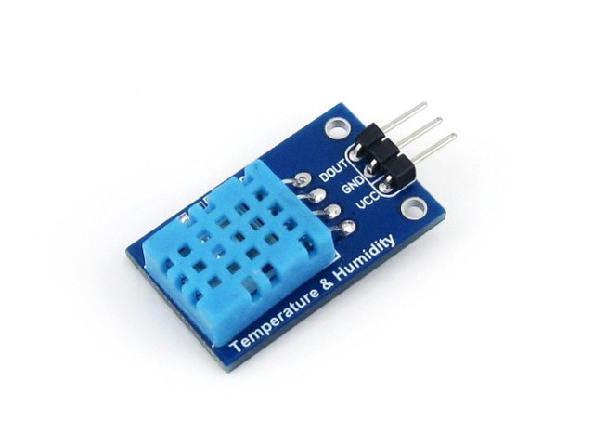

Fig:DHT11 Sensor

DHT11 is a Humidity and Temperature Sensor, which generates calibrated digital output. DHT11 can be interface with any microcontroller like Arduino, Raspberry Pi, etc. and get instantaneous results. DHT11 is a low cost humidity and temperature sensor which provides high reliability and long term stability.

**Gas Sensor:**

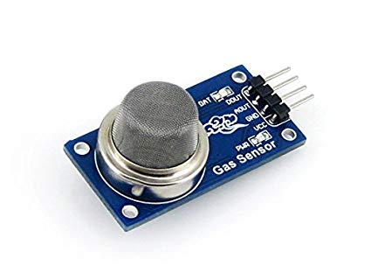

Fig:Mq135 Sensor

Gas Sensor is also called Air quality sensor for detecting a wide range of gases, including NH3, NOx, alcohol, benzene, smoke and CO2. Ideal for use in office or factory. MQ135 gas sensor has high sensitivity to Ammonia, Sulfide and Benze steam, also sensitive to smoke and other harmful gases. It is with low cost and particularly suitable for Air quality monitoring application.

**GSM Module:**

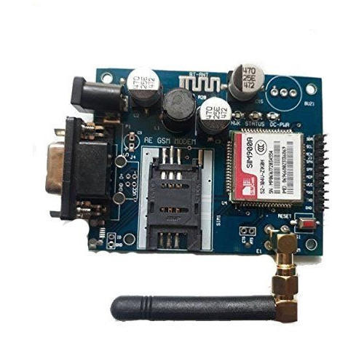

GSM is a mobile communication modem; it is stands for global system for mobile communication (GSM). The idea of GSM was developed at Bell Laboratories in 1970.  It is widely used mobile communication system in the world. GSM is an open and digital cellular technology used for transmitting mobile voice and data services operates at the 850MHz, 900MHz, 1800MHz and 1900MHz frequency bands.

GSM system was developed as a digital system using time division multiple access (TDMA) technique for communication purpose. A GSM digitizes and reduces the data, then sends it down through a channel with two different streams of client data, each in its own particular time slot. The digital system has an ability to carry 64 kbps to 120 Mbps of data rates.

**Bread board and Connecting wires:**

A modern solder less breadboard consists of a perforated block of plastic with numerous tin plated phosphor bronze or nickel silver alloy spring clips under the perforations. The clips are often called tie points or contact points. The number of tie points is often given in the specification of the breadboard. The spacing between the clips (lead pitch) is typically 0.1 in (2.54 mm). Integrated circuits (ICs) in dual in-line packages (DIPs) can be inserted to straddle the centreline of the block. Interconnecting wires and the leads of discrete components (such as capacitors, resistors, and inductors) can be inserted into the remaining free holes to complete the circuit. Where ICs are not used, discrete components and connecting wires may use any of the holes. A breadboard is utilized to build and test circuits expeditiously afore finalizing any circuit design. The breadboard has many apertures into which route components like ICs and resistors can be connected.. A typical breadboard that includes top and bottom power distribution rails. Jump wires are generally used to establish connectivity with bread board.

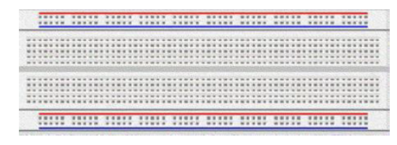



**SOFTWARE REQUIREMENTS**:

**Arduino IDE**:

The Arduino is open source Integrated Development Environment or Arduino Software (IDE). It contains a text editor for writing code, a message area, a text console, a toolbar with buttons for common functions and a series of menus.

PROCEDURE

In this we tell about how to make use of the recent advancements in technology for monitoring the weather.The implementation starts by inserting a sim card in the GSM module. And make sure we have power supply. The Using the sensors DHT11 and MQ135 we will read the analog values as A0,A1.The output of these sensors is carried as inputs to the Arduino . And thus read the values of temperature,humidity and air quality from the surrounding environment. The values of the outcomes will be displayed on the Serial monitor. The GSM module pushes the sensed values in the form of notifications to any desired mobile number.

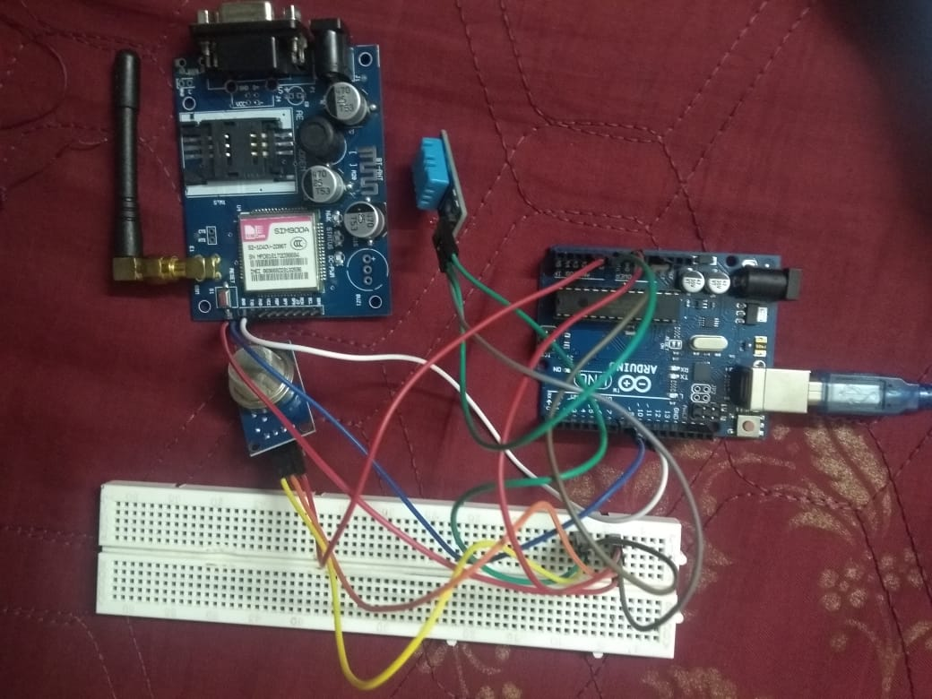

Circuit diagram

SAMPLE CODE

#include <dht.h>  
#define dht_apin A0   
#include <SoftwareSerial.h>  
  
SoftwareSerial mySerial(9, 10);  
 dht DHT;  
int airquality = 0;  
  
 void setup()

{  
  mySerial.begin(9600);  
 Serial.begin(9600);  
  delay(500);  
  delay(1000);  
 }

 void loop()

{  
     DHT.read11(dht_apin);  
    Serial.print("Current humidity = ");  
    Serial.print(DHT.humidity);  
    Serial.print("%  ");  
    Serial.print("temperature = ");  
    Serial.print(DHT.temperature);   
   Serial.println("C  ");  
   delay(5000);//Wait 5 seconds before accessing sensor again.  
   int sensorValue = analogRead(A1);  
  Serial.print("Air Quality = ");  
  Serial.print(sensorValue);  
  Serial.print("*PPM");  
  Serial.println();  
  
    mySerial.println("AT+CMGF=1");      
    delay(1000);    
    mySerial.println("AT+CMGS=\"+919182508705\"\r");   
    delay(1000);  
  
    mySerial.print("Current humidity = ");  
    mySerial.print(DHT.humidity);  
    mySerial.print("%  ");  
    mySerial.print("temperature = ");  
    mySerial.print(DHT.temperature);   
    mySerial.println("C  ");  
    mySerial.print("Air Quality = ");  
    mySerial.print(sensorValue);  
    mySerial.print("*PPM");  
    
     delay(100);  
     mySerial.println((char)26);   
     delay(1000);  
    
  delay(1000);  
}

OUTPUT:

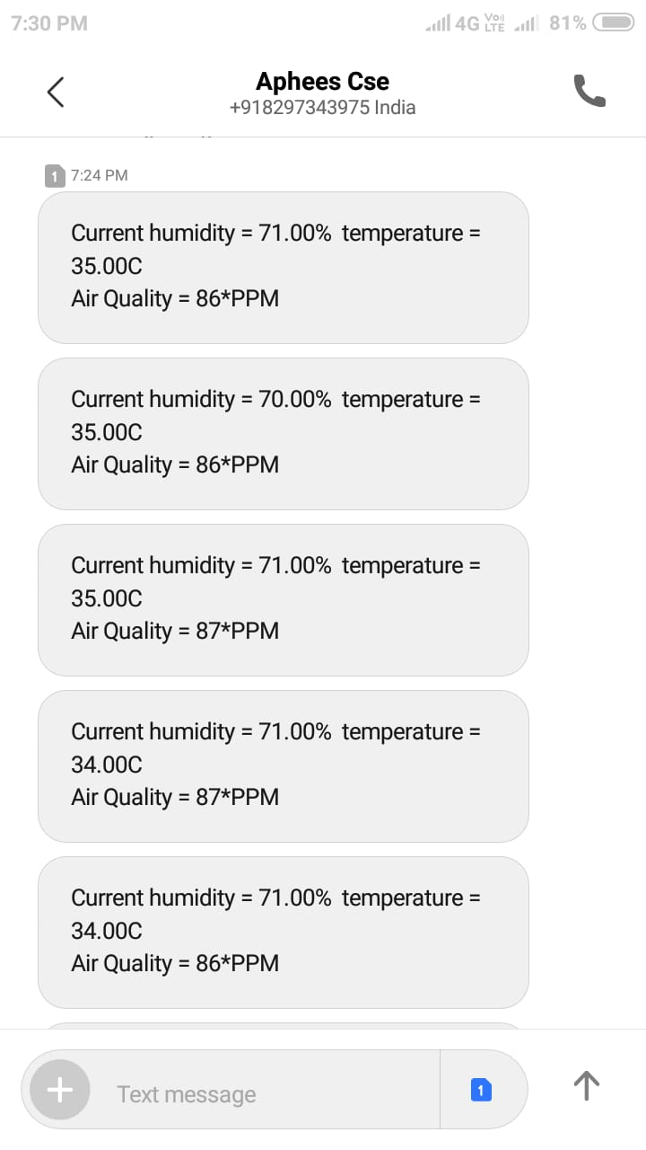

**CONCLUSION**

The embedded devices are kept in the environment to monitor the required parameters and hence enabling self protection and smart environment. To implement this it is needed to deploy the sensor devices in the environment for collecting the data and further analysis of the data. By deploying sensor devices in the environment, we can bring the environment into real life i.e. it can interact with other objects through the network. Then the collected data and analysis results will be available to the end user through the GSM. The smart way to monitor environment and an efficient, low cost embedded system is presented with different models in this paper. In the proposed architecture functions of different modules were discussed. The weather monitoring system using the Internet of Things (IoT) concept experimentally tests for monitoring two parameters. This system is aimed at making the users well aware of the weather.This data will be helpful for future analysis and it can be easily shared to other end users.

**REFERENCES**

[1] Grzegorz Lehmann, Andreas Rieger, Marco Blumendorf, SahinAlbayrakDAI, ―A 3-Layer Architecture for Smart Environment Models‖/A model-based approach /LaborTechnische University Berlin, Germany 978-1-4244 -5328-3/10 © IEEE,2010.

[2] E. Welbourne, L. Battle, G. Cole, K. Gould, K. Rector,S. Raymer et al., ―Building the internet of things usingRFID: The RFID experience,‖ IEEE internet comput.,vol. 13, no. 3, pp.48- 55, May-Jun. 2009..

[3] Shifeng Fang; Li Da Xu; Yunqiang Zhu; JiaerhengAhati; Huan Pei; Jianwu Yan; Zhihui Liu., ―An integrated system for regional environmental monitoring and management based on internet of things‖, IEEE Transactions on Industrial Informatics,vol.10, no. 2,pp.1596 -1605, May-Jun. 2014.

[4] J. A. Stankovic, ―Research directions for the Internet ofThings,‖ IEEE Internet ThingsJ., vol. 1, no. 1, pp. 3–9, Feb2014